**Lab Assignment No. 10**

**Code:**

import torch  
import torchvision  
from torchvision.models.detection import FasterRCNN  
from torchvision.transforms import functional as F  
from PIL import Image, ImageDraw  
  
model = torchvision.models.detection.fasterrcnn_resnet50_fpn(weights=True)  
  
model.eval()  
  
def transform_image(image):  
 image = F.to_tensor(image)  
 return image.unsqueeze(0)

/usr/local/lib/python3.10/dist-packages/torchvision/models/_utils.py:223: UserWarning: Arguments other than a weight enum or `None` for 'weights' are deprecated since 0.13 and may be removed in the future. The current behavior is equivalent to passing `weights=FasterRCNN_ResNet50_FPN_Weights.COCO_V1`. You can also use `weights=FasterRCNN_ResNet50_FPN_Weights.DEFAULT` to get the most up-to-date weights.  
 warnings.warn(msg)

def calculate_area(box):  
 maxX = max(box[0], box[2])  
 maxY = max(box[1], box[3])  
 minX = min(box[0], box[2])  
 minY = min(box[1], box[3])  
 width = (maxX-minX)  
 height = (maxY-minY)  
 return width*height

def calculate_iou(box1, box2):  
 # Calculate the intersection area  
 x1 = max(box1[0], box2[0])  
 y1 = max(box1[1], box2[1])  
 x2 = min(box1[2], box2[2])  
 y2 = min(box1[3], box2[3])  
 intersection_area = max(0, x2 - x1 + 1) * max(0, y2 - y1 + 1)  
  
 # Calculate the union area  
 box1_area = (box1[2] - box1[0] + 1) * (box1[3] - box1[1] + 1)  
 box2_area = (box2[2] - box2[0] + 1) * (box2[3] - box2[1] + 1)  
 union_area = box1_area + box2_area - intersection_area  
  
 # Calculate the IoU  
 iou = intersection_area / union_area  
 return iou

def max_area_box(boxes, threshold):  
 maxArea = []  
 maxAreaBox = []  
 for box1 in boxes:  
 for box2 in boxes:  
 if box1 != box2:  
 iou = calculate_iou(box1, box2)  
 if iou < threshold:  
 calAB1 = calculate_area(box1)  
 calAB2 = calculate_area(box2)  
 maxBox = max(calAB1, calAB2)  
 # print(maxBox)  
 if maxBox not in maxArea:  
 maxArea.append(maxBox)  
 if maxBox == calAB1:  
 if box1 not in maxAreaBox:  
 maxAreaBox.append(box1)  
 if maxBox == calAB2:  
 if box2 not in maxAreaBox:  
 maxAreaBox.append(box2)  
  
 return {"MaxArea":maxArea, "MaxAreaBox":maxAreaBox}

def detect_object(img, threshold):  
 image_path = img  
 image = Image.open(image_path).convert("RGB")  
 transformed_image = transform_image(image)  
  
 with torch.no_grad():  
 predictions = model(transformed_image)  
  
 boxes = predictions[0]['boxes'].tolist()  
 scores = predictions[0]['scores'].tolist()  
 labels = predictions[0]['labels'].tolist()  
  
 draw = ImageDraw.Draw(image)  
 # print(max_area_box(boxes)['MaxAreaBox'])  
 for box in max_area_box(boxes, threshold)['MaxAreaBox']:  
 draw.rectangle(box, outline='red', width=3)  
  
 image.show()  
 # print(score)

detect_object('/content/dog.jpg', 0.3)

**Output:**

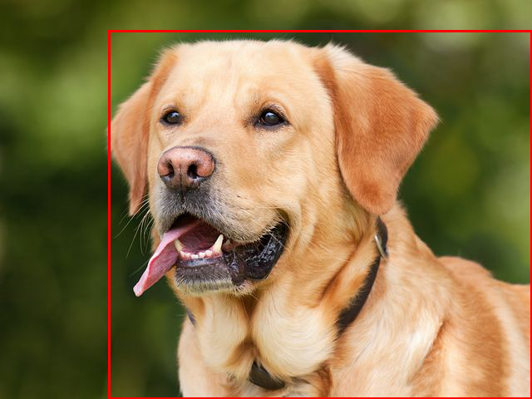

detect_object('/content/manwithdog.jpeg', 0.36)

Accuracy 0.89 loss 0.076

